October 3rd 2024
Special Guest Speaker
Monsters in the Dark

by

Dr Mathew Bothwell

November 7th 2024
Southern Night Sky Wonders

by

David Pugh

December 5th 2024
Christmas Quiz and Social

by

Roger Sidwell.

Monthly events include the usual items “Monthly Night Sky”, “Astro News” and Raffle.

CDAA
The United Reform Church
Carnarvon Road
Clacton on Sea
At
7:30 pm
First Thursday of each month (except August)

New members and visitors always welcome
(Visitors fee £2.00)

Contact email:
bob.leon@tiscali.co.uk

website:

http://www.clactonastronomy.co.uk

Please Note – Some items may be subject to change. If so, members will be advised accordingly

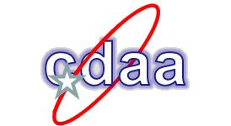

Meeting ProgramMe

2024
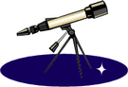

Meeting Events
January 4th 2024
William Herschel

by

David Pugh

February 1st 2024
Brian Cottis Memorial Lecture

The Lives of Stars

by

Mike Haynes

March 7th 2024
Latest Astronomical Research

by

Mike Haynes

April 4th 2024
Special Guest Speaker
Cosmology Overview

by

by Jonathan Clough

May 2nd 2024
Latest Astronomical Research

by

Mike Haynes

June 6th 2024
Elements and the Periodic Table – Where do the Elements come from?

by

Bob Leon

July 4th 2024
Special Guest Speaker
The Moon

by

Jerry Workman

No August Meeting

September 5th 2024
The A.G.M.
Followed by:
Members Night –
A series of Short Talks

by

Members

